Error Handling
Objectives
At the end of this session, the student will be able to:
- Working with Exceptions
- Using TRY…CATCH
- Display error information

SQL Server provides the TRY…CATCH statement that helps to handle
errors eﬀectvely at the back end.

- Execute following code:
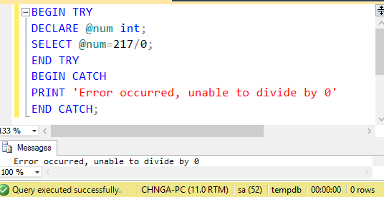

Error functions:
- System functions are as follows:
  - ERROR_NUMBER(): returns the number of error.
  - ERROR_SEVERITY(): returns the severity.
  - ERROR_STATE(): returns state number of the error.
  - ERROR_PROCEDURE(): returns the name of the trigger or stored procedure where the error occurred.
  - ERROR_LINE(): returns the line number that caused the error.
  - ERROR_MESSAGE(): returns the complete text of the error. The text contains the value supplied for the parameters such as object names, length, or times.
Change above code to display error information:
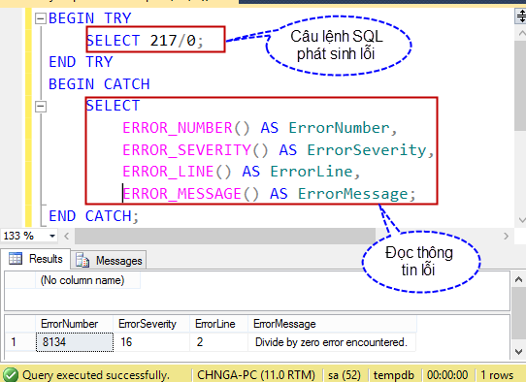

- Using TRY…CATCH with transaction
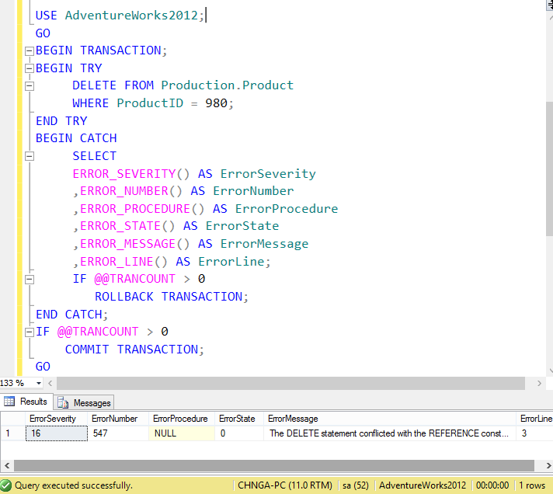

- Using RAISERROR to display an error message :
